AIPP LAB 8
Name: CH HARSHITHA
Hall Ticket No.: 2503B05135
___________________________________________________
Completed this Assignment using Cursor Al Integration and Generated Test Cases directly though ChatBox.
Task 1:
Use AI to generate test cases for is_valid_email(email) and then implement the validator function.
CODE:
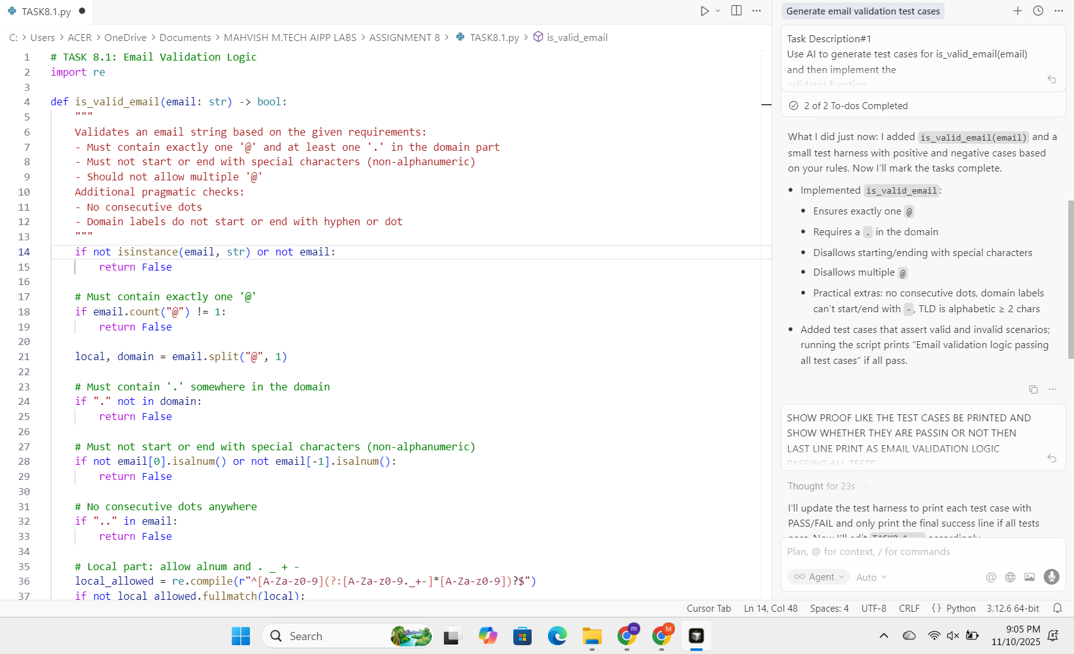
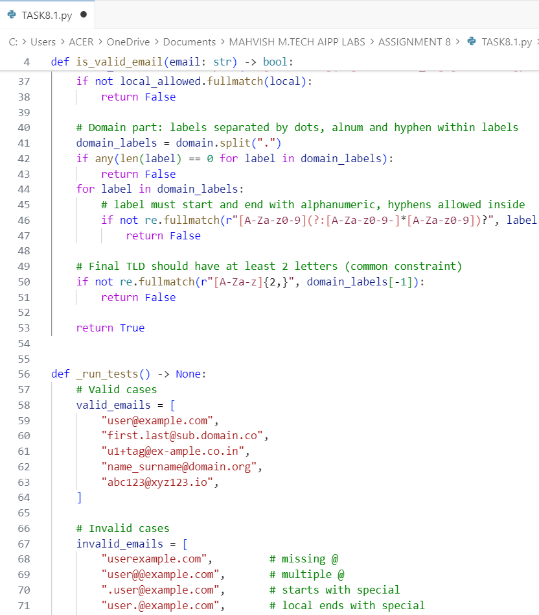
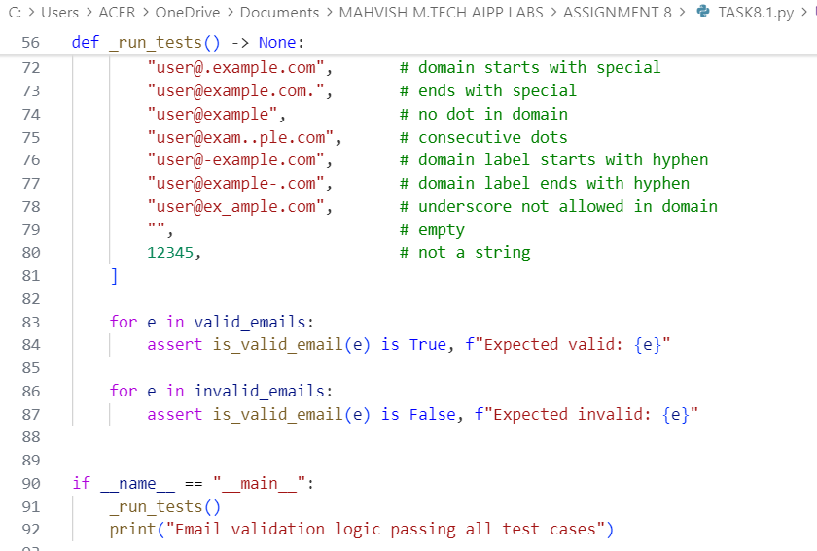
OUTPUT:
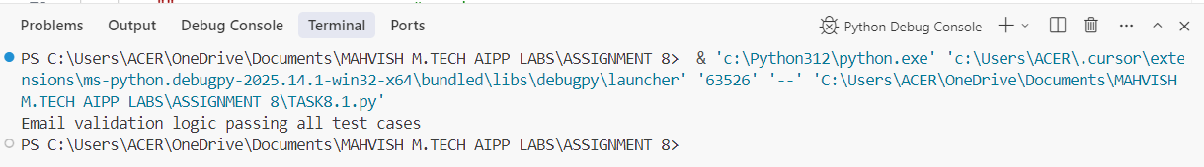
Task 2:
Ask AI to generate test cases for assign_grade(score) function. Handle boundary and invalid inputs.
CODE:
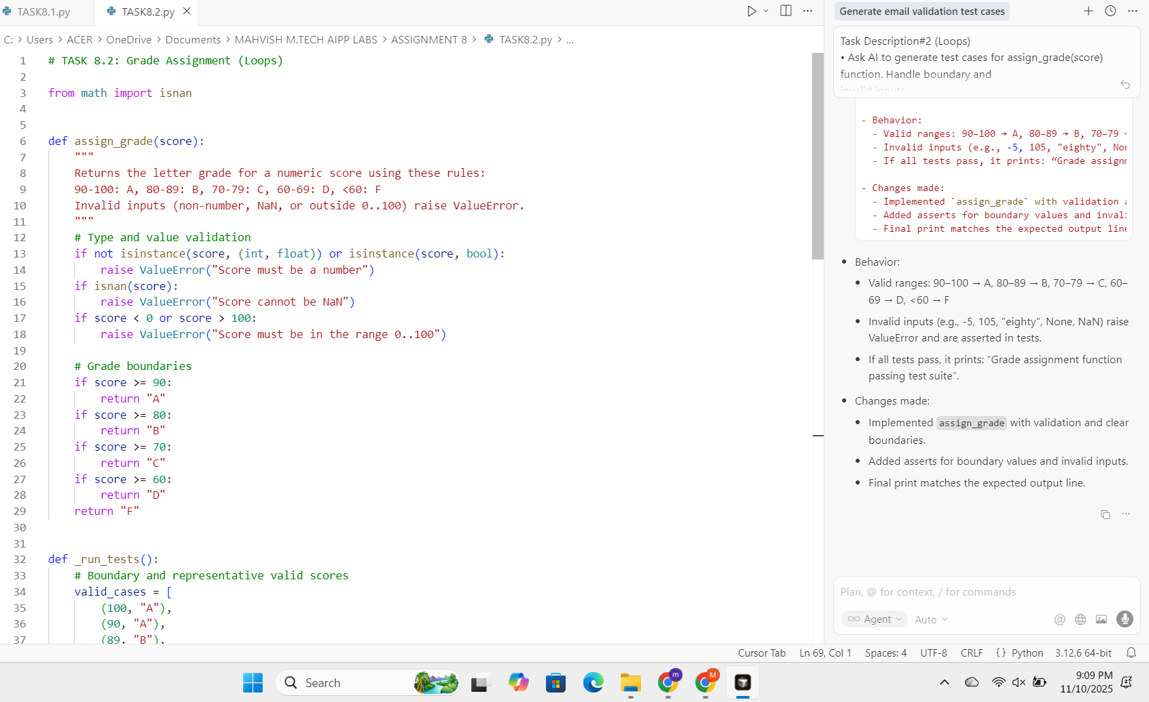

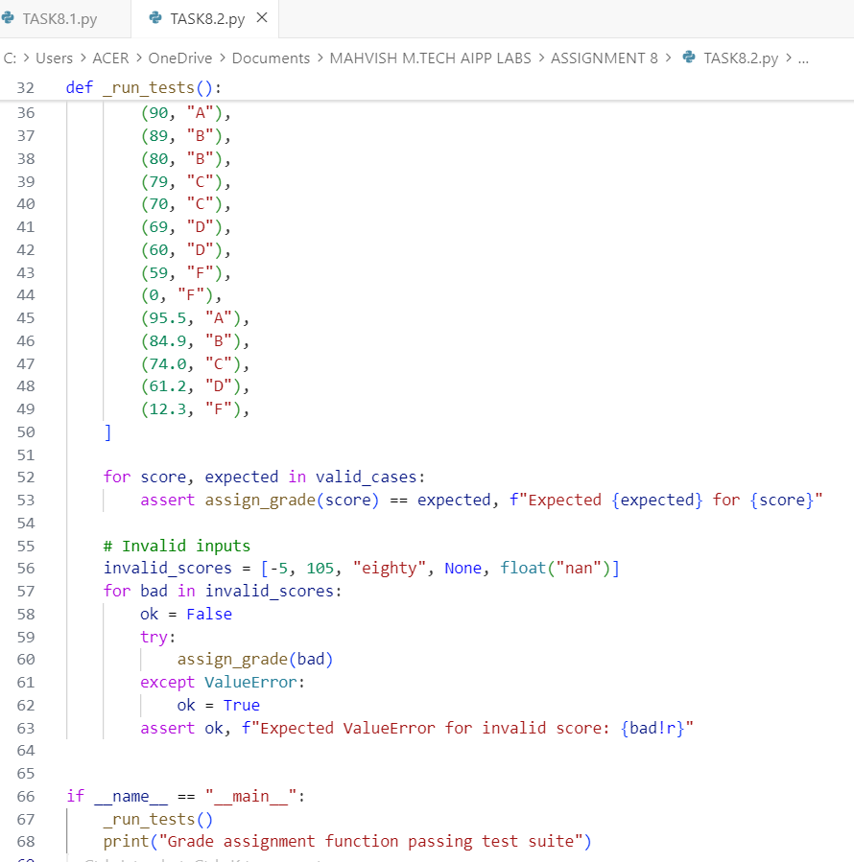
OUTPUT:
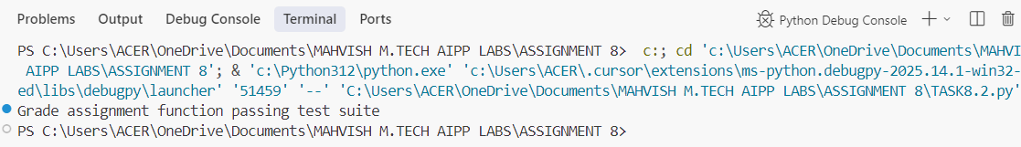
Task 3:
Generate test cases using AI for is_sentence_palindrome(sentence). Ignore case, punctuation, and spaces.
CODE:
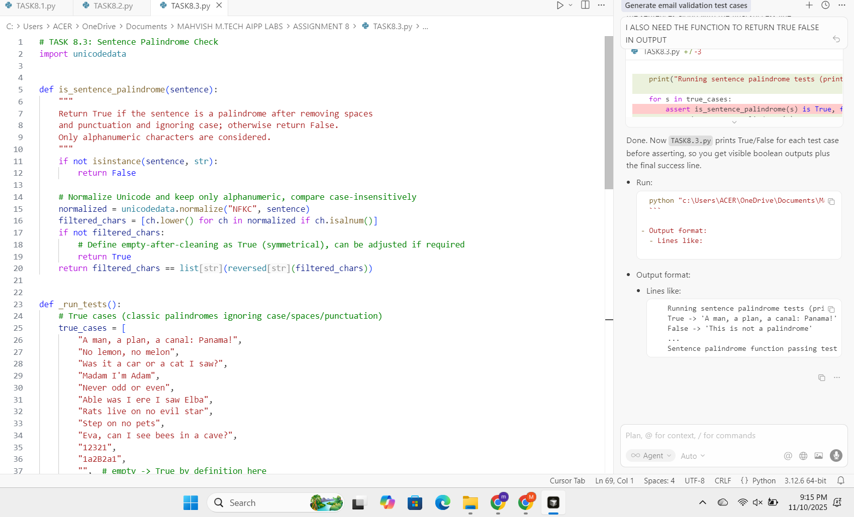
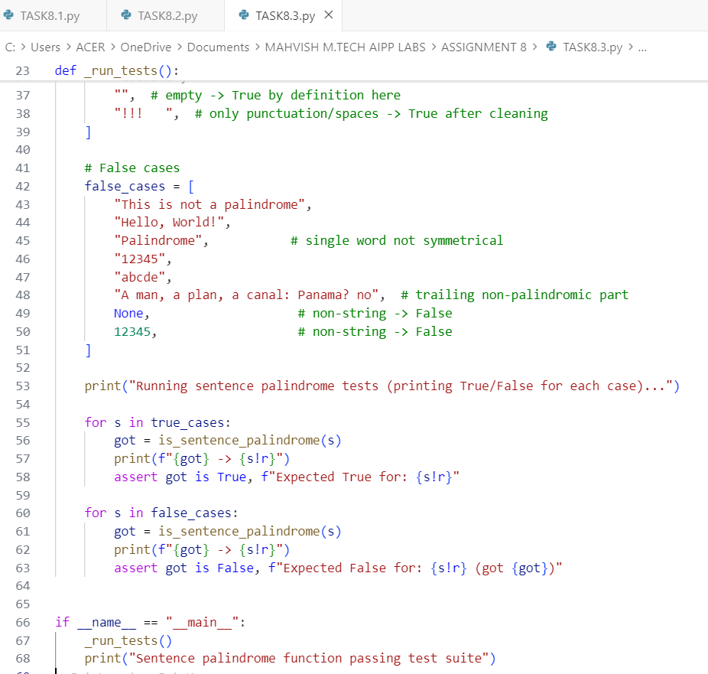
OUTPUT:
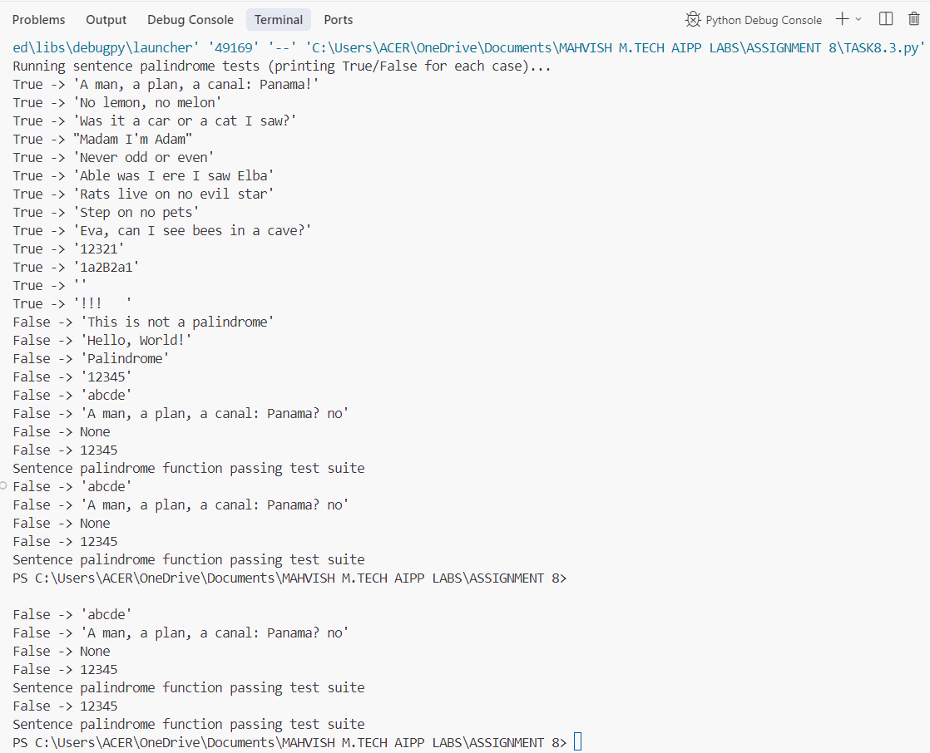
Task 4:
Let AI fix it Prompt AI to generate test cases for a ShoppingCart class (add_item, remove_item, total_cost).
CODE:
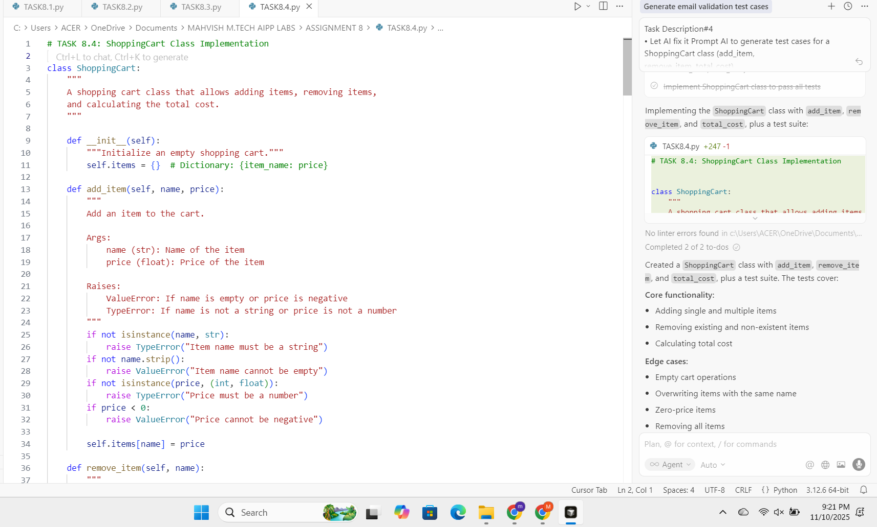
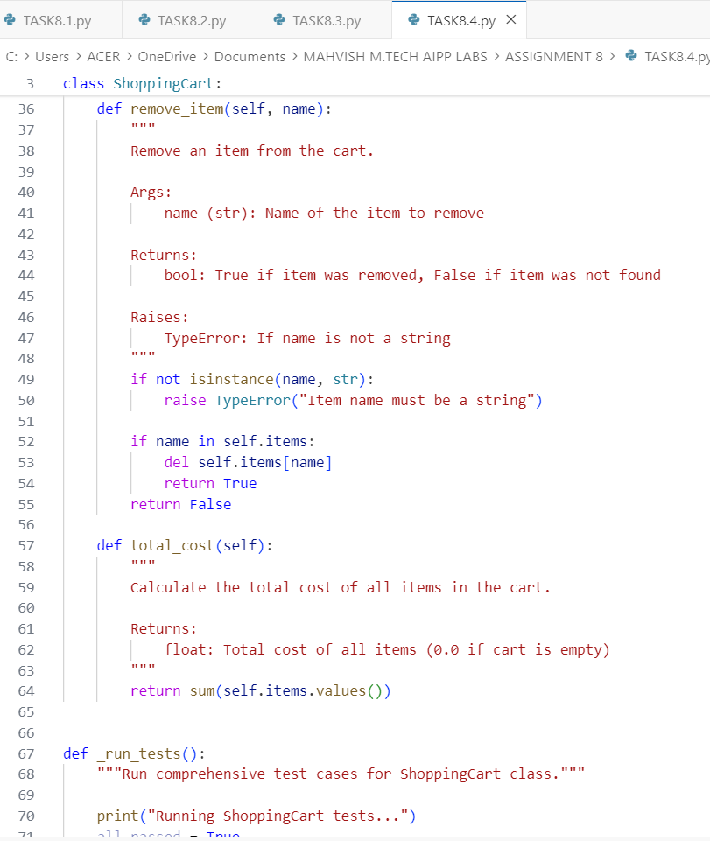
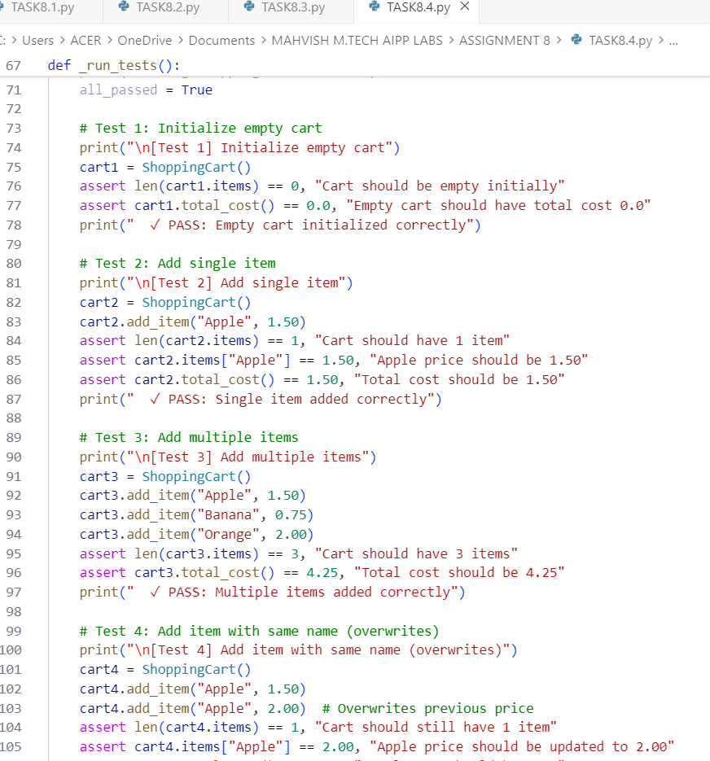
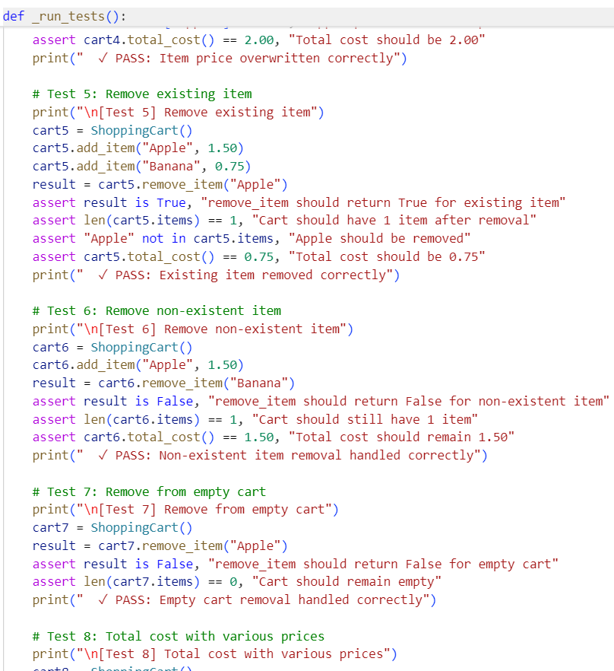
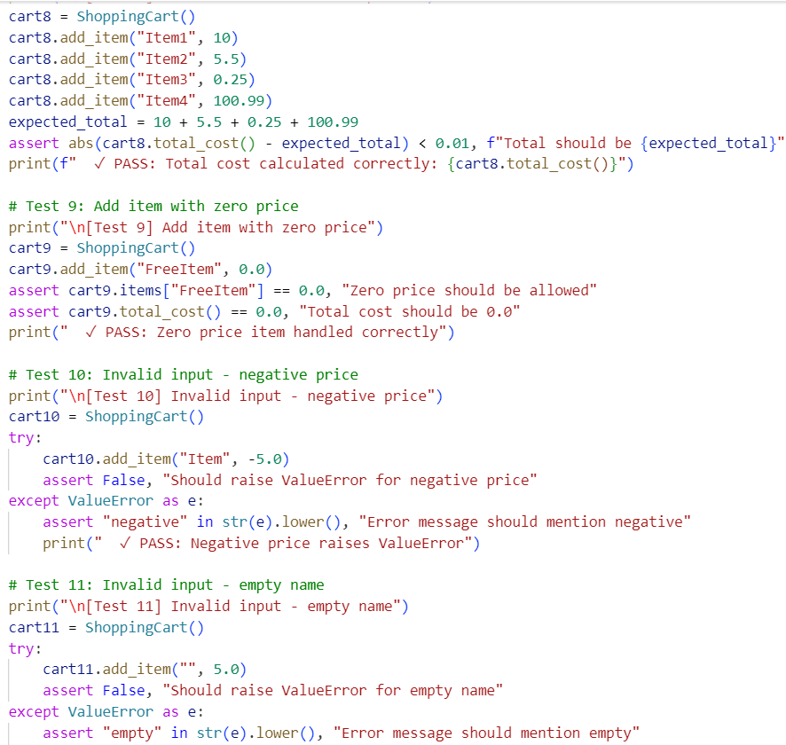
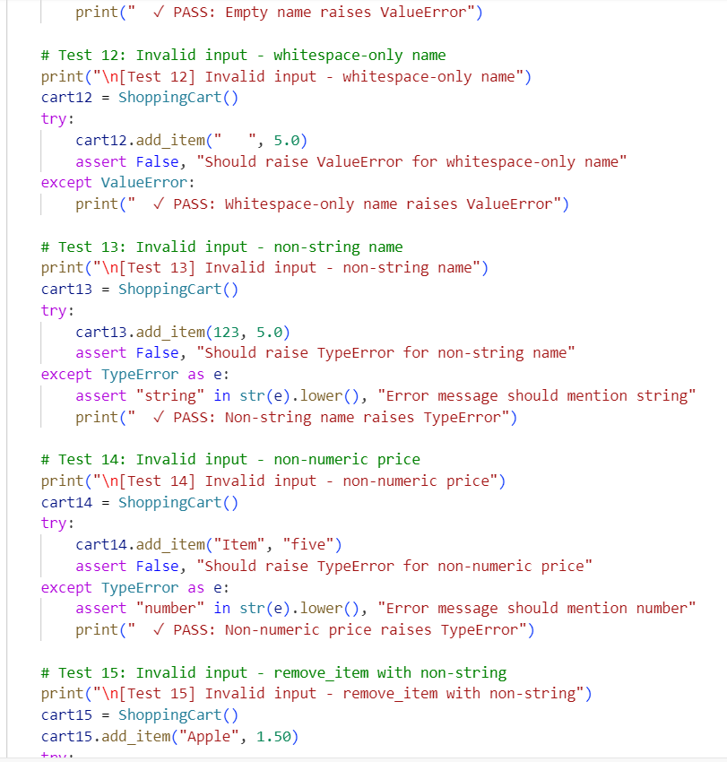
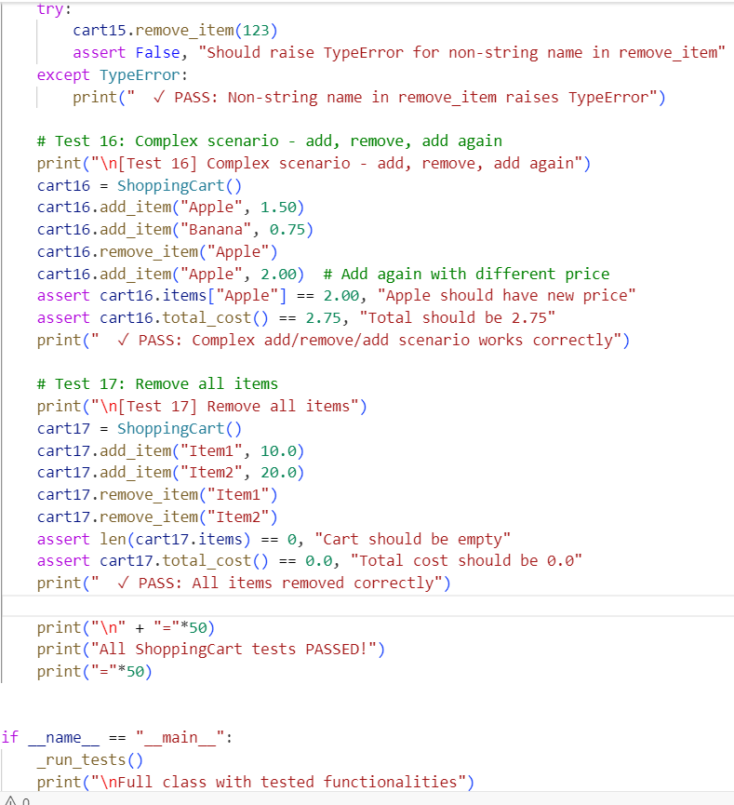
OUTPUT:
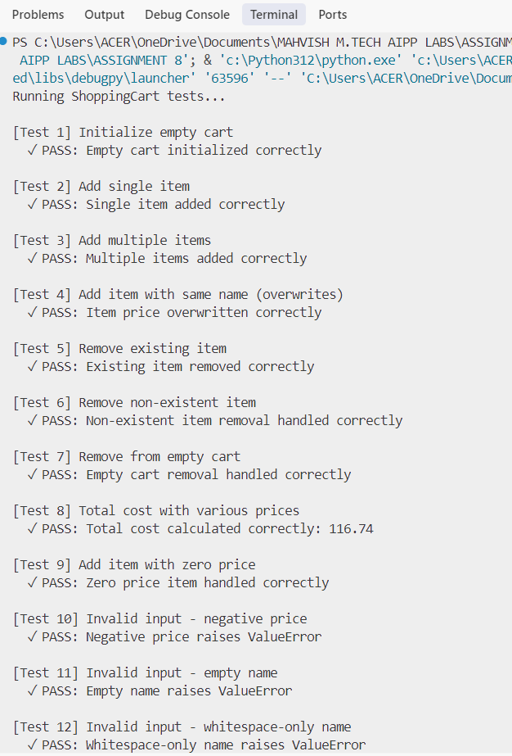

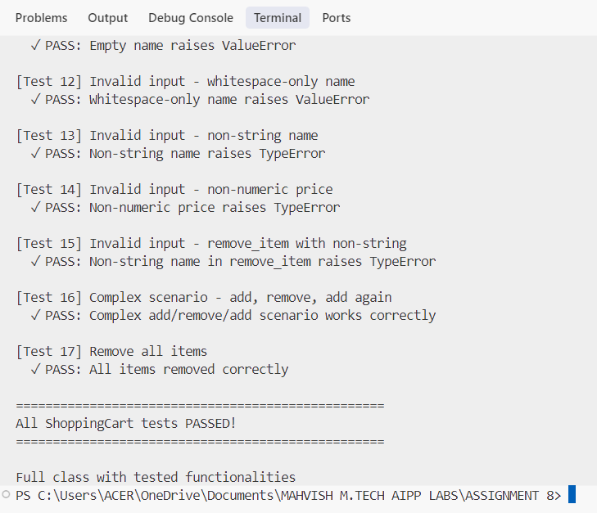

Task 5:
Use AI to write test cases for convert_date_format(date_str) to switch from "YYYY-MM-DD" to "DD-MM-YYYY".
Example: "2023-10-15" → "15-10-2023"
CODE:
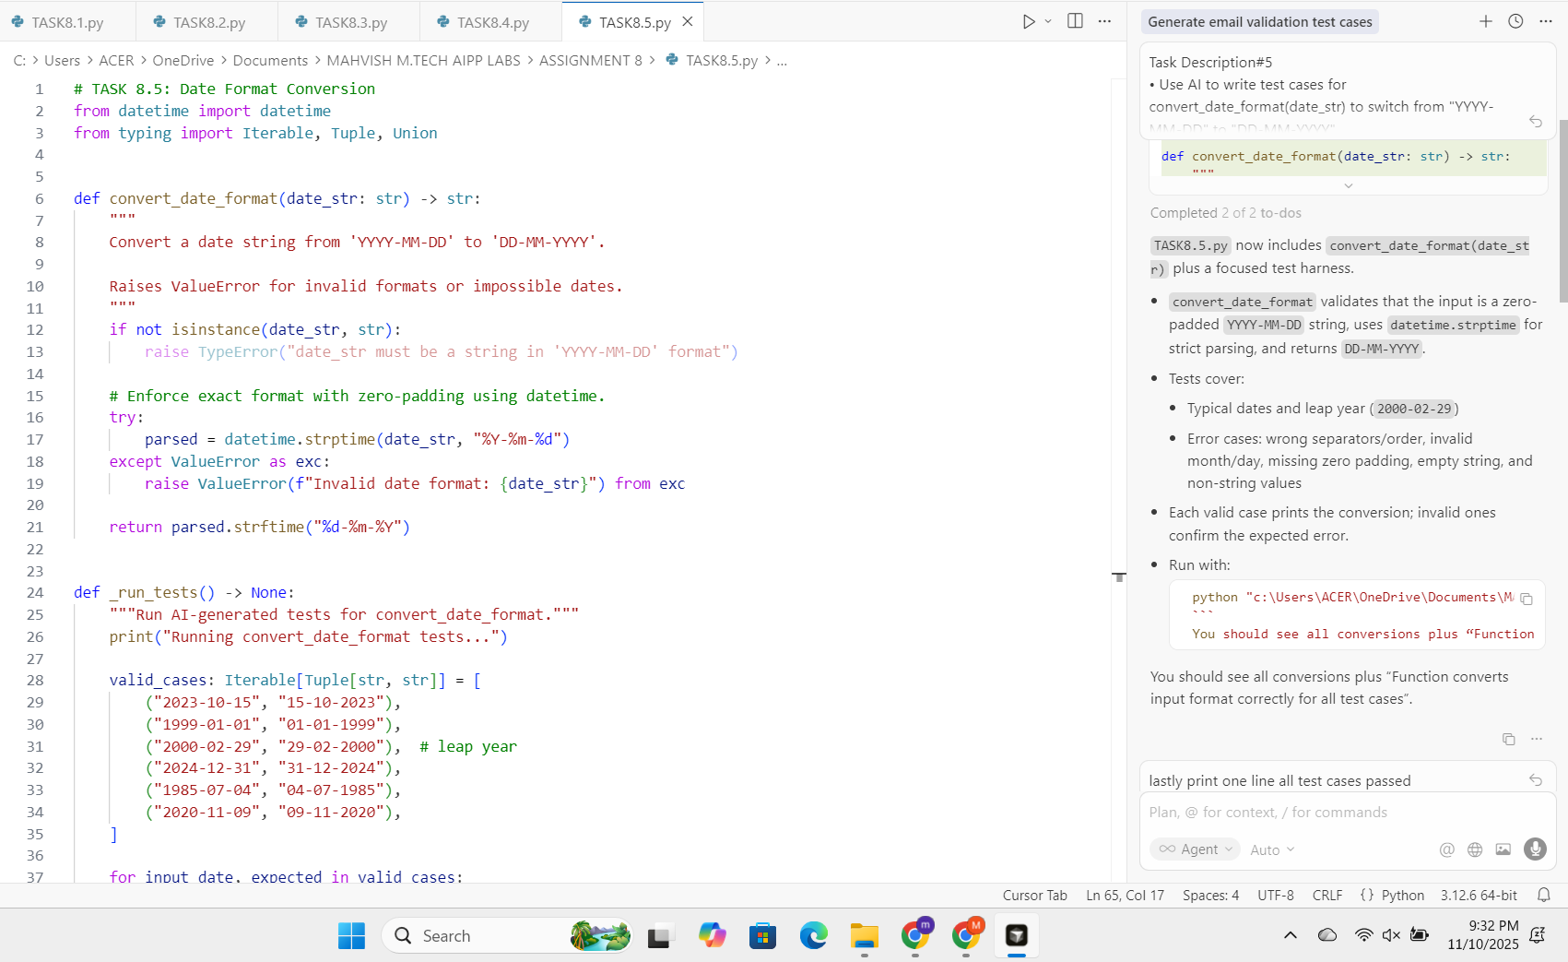
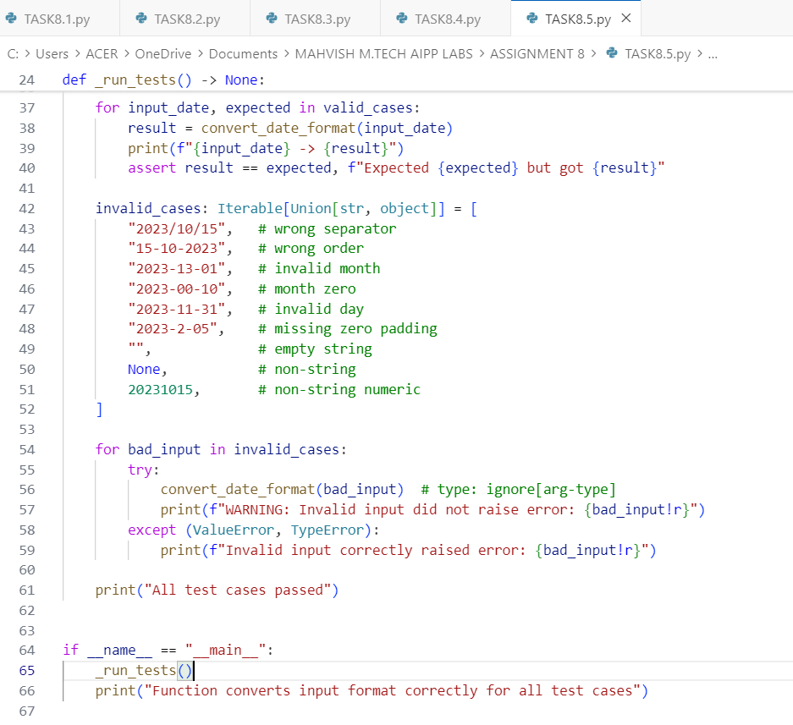
OUTPUT:



